Hi Whats up guys ? In this face recognition for Attendance System we want to install some pakages and make sure again we want to install visual stdio 2019 version for install Dlib

Follow the given steps below:

Step:1 You Make sure to clone the code by using the given command given below:

<https://github.com/Balasubramaniam077/Face_Recognition.git>

Step:2 In this step we want to download and install visual stdio 2019 version using the given link below:

<https://visualstudio.microsoft.com/downloads/>

Step:3 After download the visual stdio 2019. You want to install Desktop development with c++

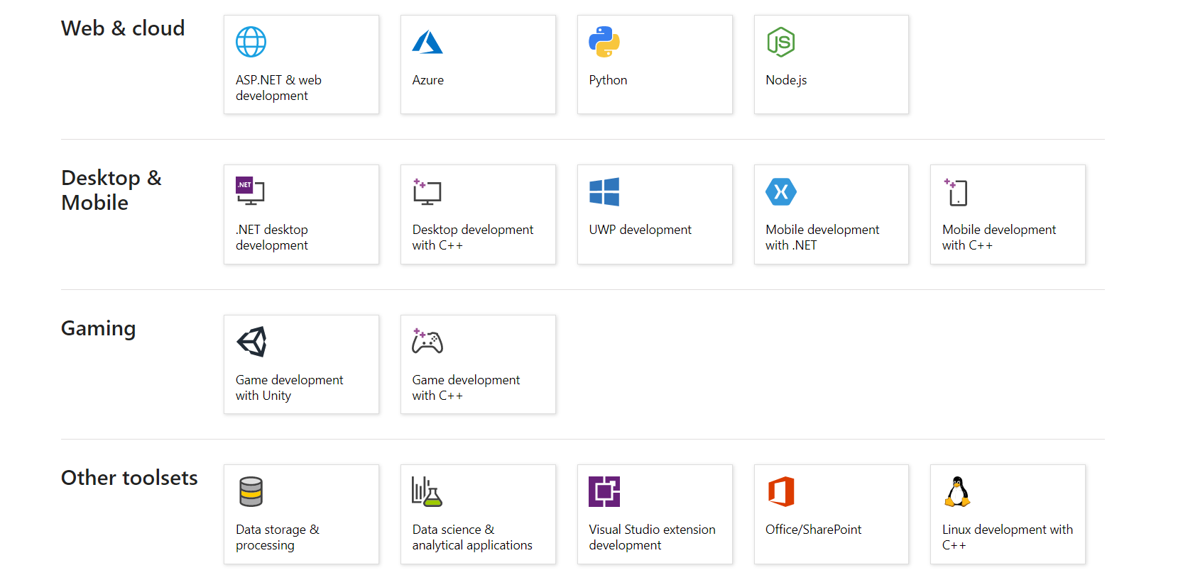

Step:4 Now you want to install requirements lib for face recognition for attendance system using the given commands given below:

Pip install -r requirements.txt

Step:5 Now Run the python file using the given command given below:

Python Face_Recognition_For_Attendance